# Task 7 Report: Identify and Remove Suspicious Browser Extensions

## Objective:

Learned how to spot and remove potentially harmful browser extensions.

## Tools Used:

Web Browser: Google Chrome  
Accessed via: chrome://extensions/

## Steps Performed:

- Opened Extensions Page (chrome://extensions/)

- Reviewed all installed extensions: 360 Internet Protection, DeepSeek AI, Google Docs Offline, Malwarebytes Browser Guard, McAfee WebAdvisor, Sider

- Checked permissions and purpose of each extension via Chrome Web Store

- Identified suspicious/unused extensions: Sider, DeepSeek AI, 360 Internet Protection

- Removed 3 extensions deemed unnecessary or suspicious

- Restarted browser and observed improved performance

- Read about risks of malicious extensions (data theft, ads, phishing)

- Saved screenshots and documented findings

## List of Suspicious Extensions Removed:

|  |  |  |
| --- | --- | --- |
| Extension Name | Reason for Removal | Status |
| 360 Internet Protection | Duplicate with other antivirus | Removed |
| DeepSeek AI | AI tool not in active use | Removed |
| Sider | Overlapping functionality, unused | Removed |

Date: 05-June-2025

Student: Surya

## Screenshots of Chrome Extensions

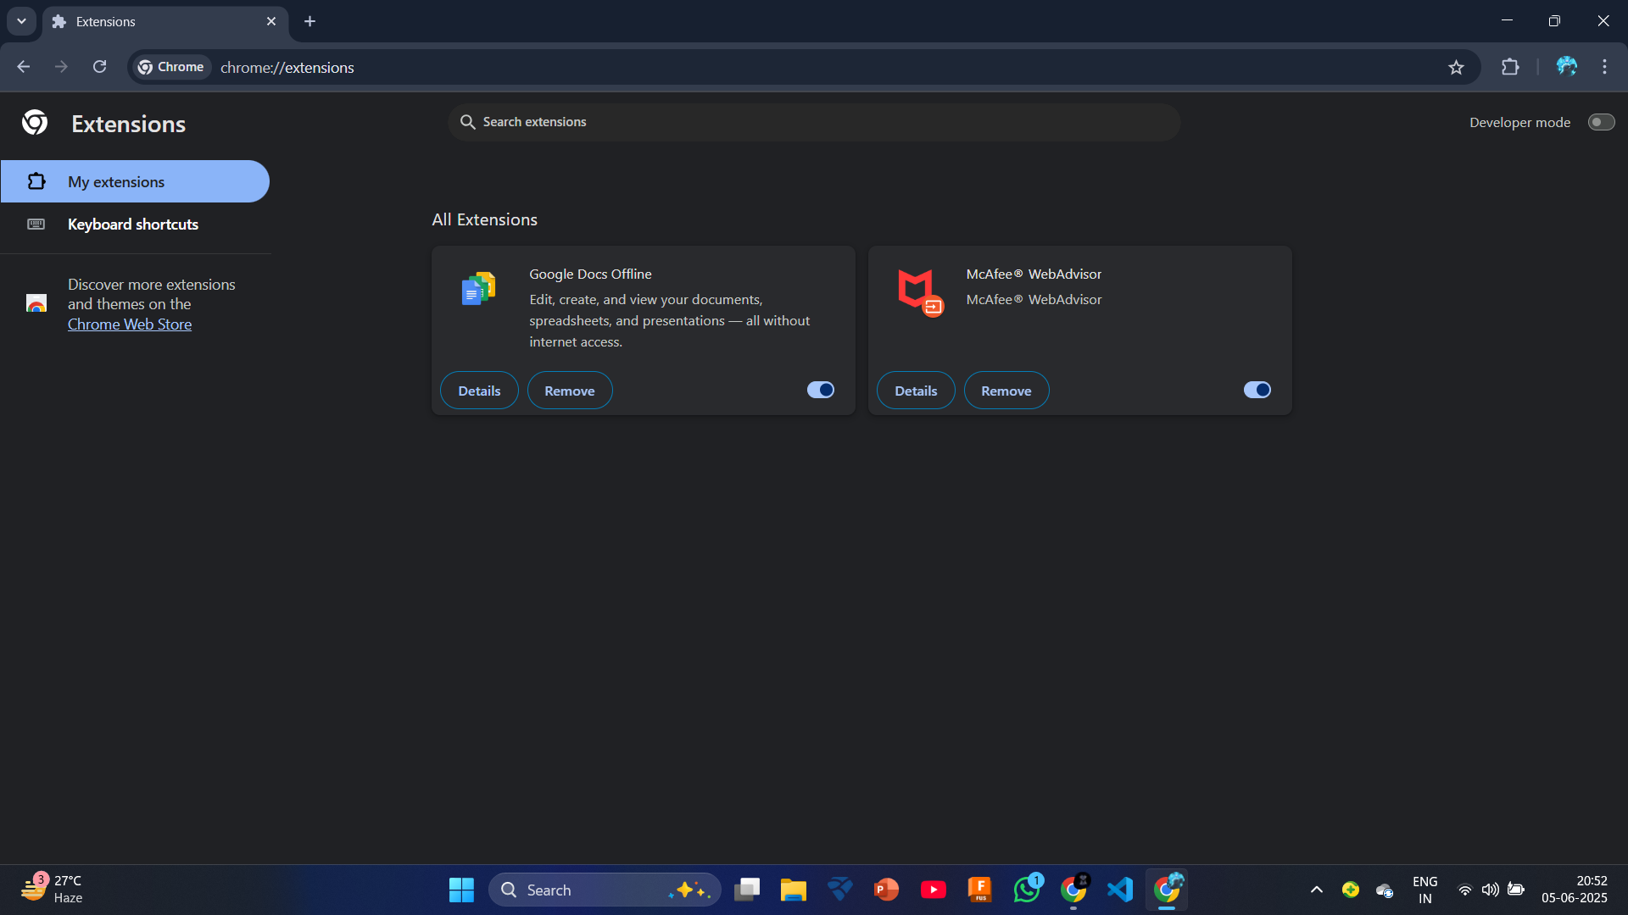

Installed Extensions Overview

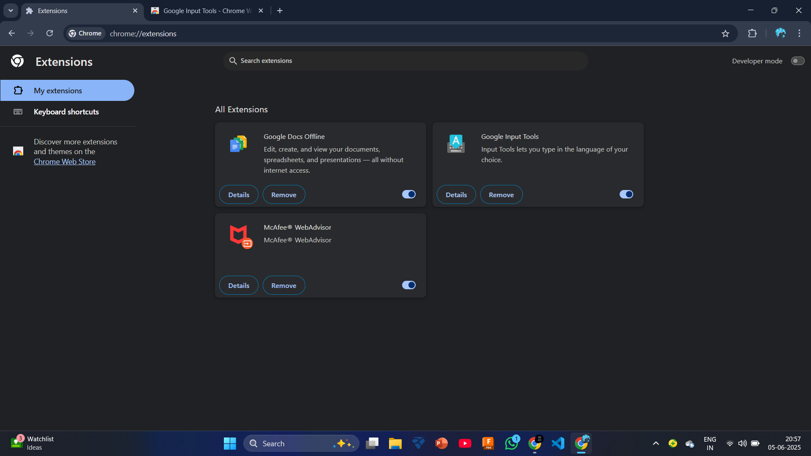

Details of Google Input Tools Extension

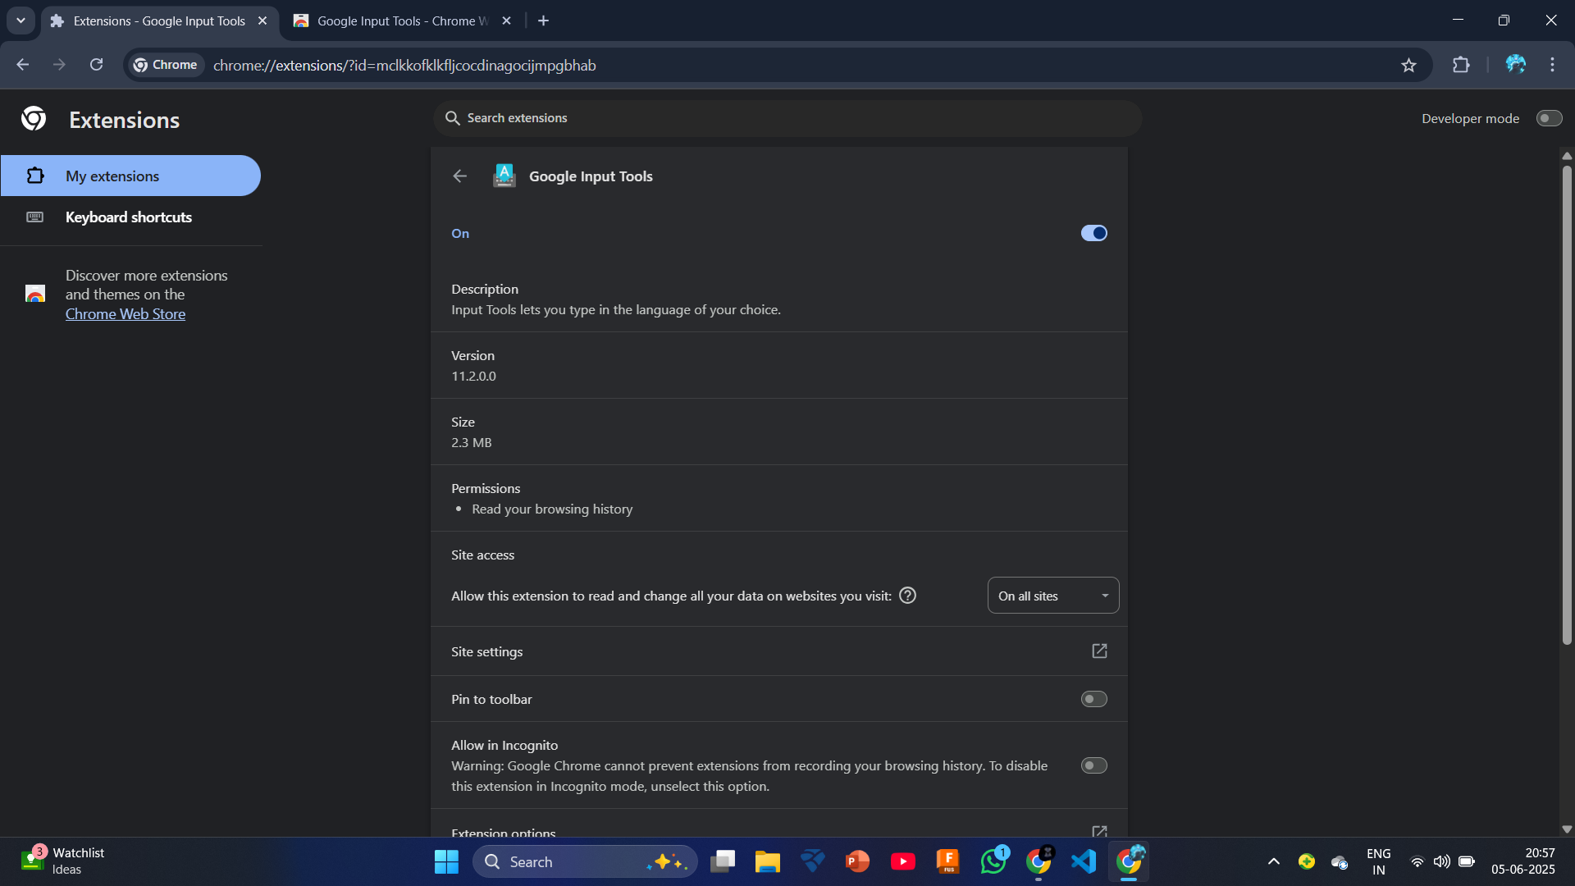

Remaining Extensions After Removal